Web Development



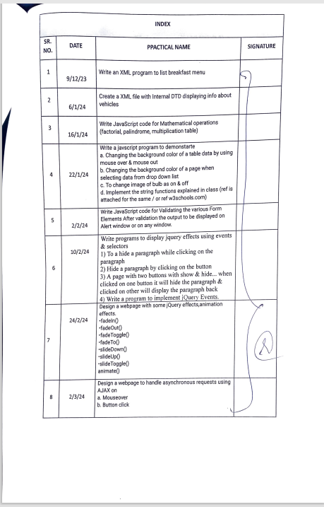

practical-1

Write an XML program to list breakfast menu

Code:

<?xml version="1.0"?>

<breakfast_menu>

<food>

<name>Belgian Waffles</name>

<price>Rs.200</price>

<description>Two of our famous belgian waffes with plenty of real maple syrup </description>

<calories>650</calories>

</food>

<food>

<name>Cheese Sandwich</name>

<price>Rs.60</price>

<description>Consists of vegetables and sliced cheese</description>

<calories>340</calories>

</food>

<food>

<name>Bread Pudding</name>

<price>Rs.110</price>

<description>Soft,spongy and thick texture</description>

<calories>200</calories>

</food>

<food>

<name>French toast with butter</name>

<price>Rs.50</price>

<description>crispy and crunchy</description>

<calories>178</calories>

</food>

<food>

<name>Pancake</name>

<price>Rs. 140</price>

<description>A crisp exterior and a soft interior</description>

<calories>227</calories>

</food>

</breakfast_menu>

Output:

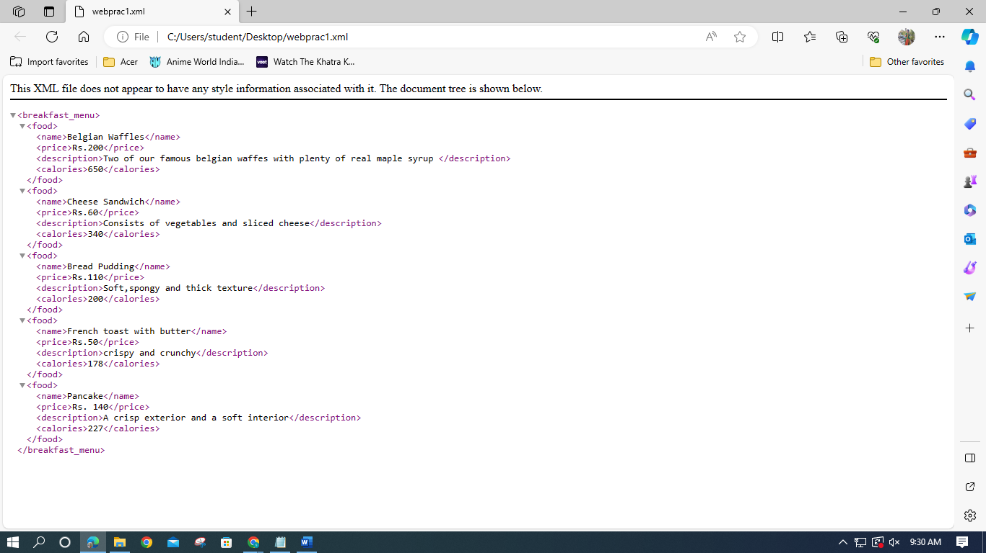

**PRACTICAL 2**

Create a XML file  
with Internal DTD displaying info about vehicles

CODE

<?xml version="1.0"?>

<!DOCTYPE Veicles[00

<!ELEMENT Vehicles (car)>

<!ELEMENT car (name,price,description)>

<!ELEMENT name (#PCDATA)>

<!ELEMENT price (#PCDATA)>

<!ELEMENT description (#PCDATA)>

]>

<Vehicles>

<car>

<name>Mercedes</name>

<price>48.40 Lakh</price>

<description>The brand is known for its precision engineering and attention to detail, which is a hallmark of German manufacturing.</description>

</car>

<car>

<name>BMW</name>

<price>43.50 Lakh</price>

<description>BMW's vehicles are designed with the driver in mind, offering a balance of comfort, agility, and responsiveness</description>

</car>

<car>

<name>Hyundai</name>

<price>10.87 Lakh</price>

<description>Hyundai Motor Company has served as the trailblazer of Korea's automobile industry since rolling out its Pony, developed with its own exclusive technology.</description>

</car>

<car>

<name>Toyota</name>

<price>2.10 Lakh</price>

<description>Toyota cars have earned a reputation for reliability, durability, and quality. They are known for their excellent safety features and luxurious interiors.</description>

</car>

<car>

<name>Honda</name>

<price>7.13 Lakh</price>

<description>Honda cars are very well-known for their long-lasting performance and low maintenance requirements, making them an excellent choice for any car enthusiast or any car owner.</description>

</car>

</Vehicles>

OUTPUT

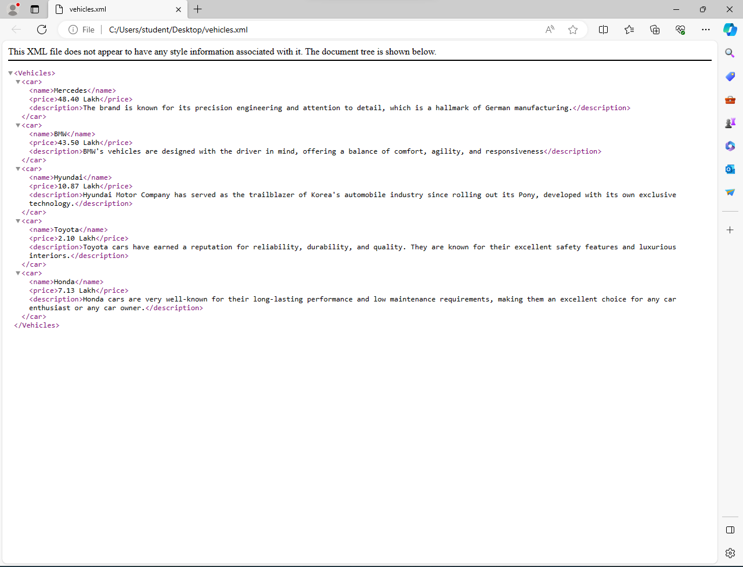

**PRACTICAL 3: JAVASCRIPT**

Write JavaScript code for Mathematical  
operations (factorial, palindrome, multiplication table)

1. **FACTORIAL OF A NUMBER:**

**CODE:**

<html>

<head>

<title> FACTORIAL </title>

<body>

 <script language="javascript">

 var fact=1,i,n;

 i=window.prompt("find factorial of entered number:");

 n=window.eval(i);

 document.write("entered number:"+n);

 if(n<0){

  alert("fact cannot be found");

 }

 else {

  if(n==0){

   alert("fact is 1");

  }

  else {

   for(i=1;i<=n;i++){

    fact=fact*i;

   }

   document.write("<br> fact=" + fact);

  }

 }

 </script>

</body>

</html>

**OUTPUT:**

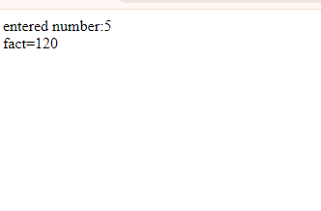

1. **PALINDRONE:**

**CODE:**

<HTML>

<head>

<title> PALINDRONE </title>

</head>

<body>

 <script language="javascript">

 var i, n, j, k, r;

 i=window.prompt("check if number is palindrone or not:","enter a number");

 n=window.eval(i);

 k=n;

 r=0;

 while(n > 0){

  j=eval(n%10);

  n=eval(parseInt(n/10));

  r=(r*10)+j;

 }

 document.write( r + " is reverse of " + k +"<br>");

 if(r==k){

  document.write(k + " is a palindrone " + "<br>");

 }

 else{

  document.write(k + "is NOT palindrone" + "<br>");

 }

 </script>

</body>

</html>

**OUTPUT:**

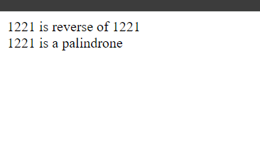

**3. MULTIPLICATION TABLE:**

**CODE:**

   <!DOCTYPE html>

<html>

<head>

  <title>Multiplication Table</title>

</head>

<body>

  <script language="javascript">

    var num = window.prompt("Enter a number for the multiplication table:");

    num = parseInt(num);

    document.write("<h2>Multiplication Table for " + num + "</h2>");

    document.write("<table border='1'>");

    document.write("<tr><th>Multiplier</th><th>Result</th></tr>");

    for (var i = 1; i <= 10; i++) {

      var result = num * i;

      document.write("<tr><td>" + num + " x " + i + "</td><td>" + result + "</td></tr>");

    }

    document.write("</table>");

  </script>

</body>

</html>

**OUTPUT:**

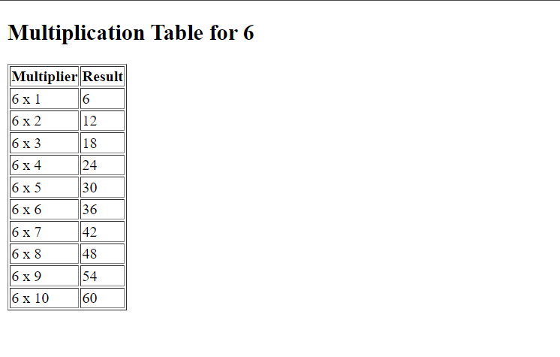

Practical 4

* Write a javascript program to demonstrate :Changing the background color of a table data by using mouse over and mouse out.

**CODE:**

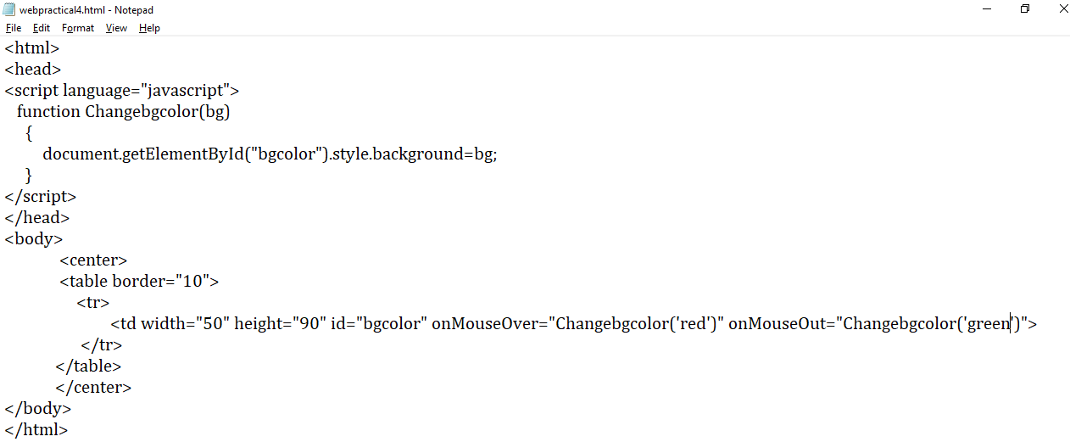

**Output:**

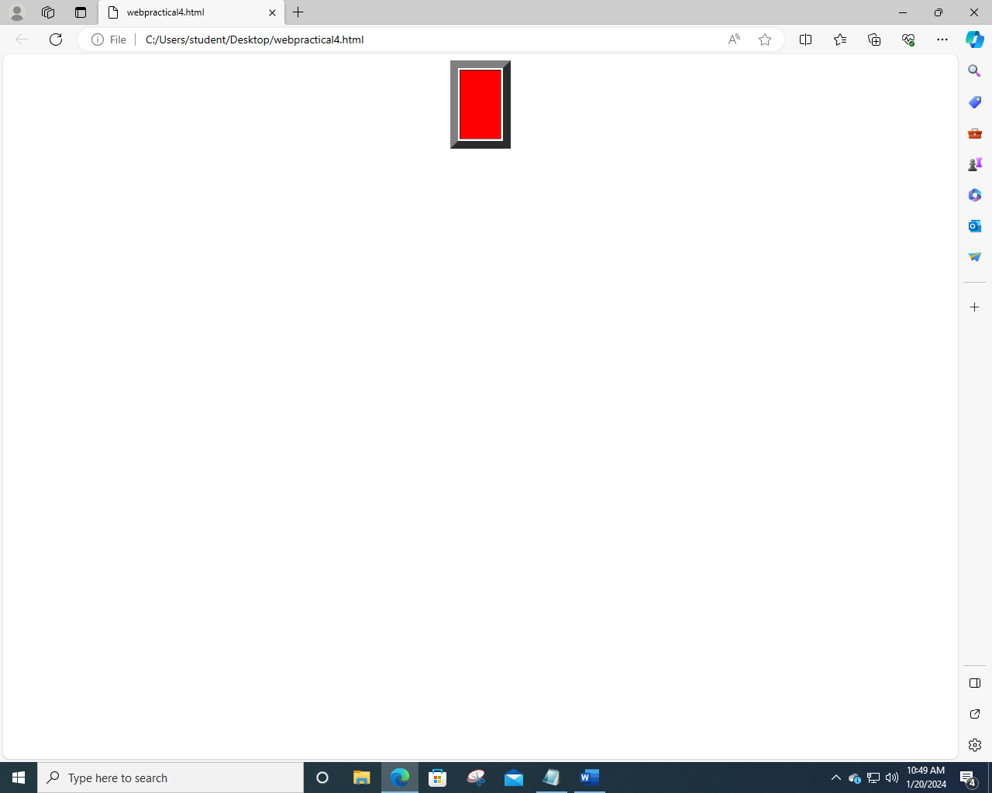

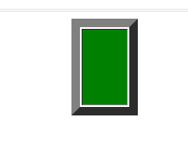

* Changing the image of bulb as on  and off.

**Code:**

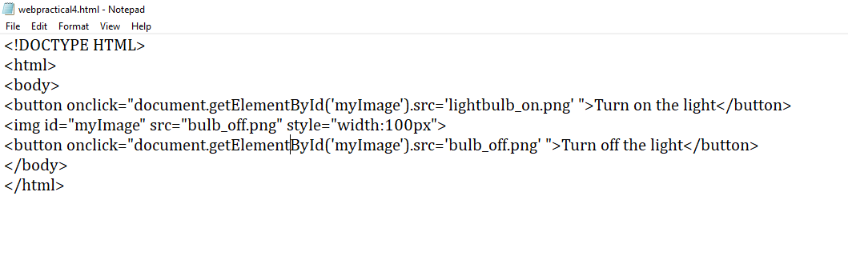

**Output:**

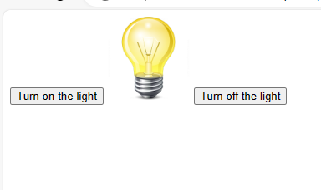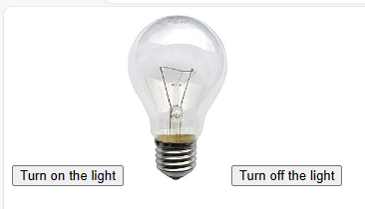

* Changing the background color of a page when selecting data from dropdown list.

**Code:**

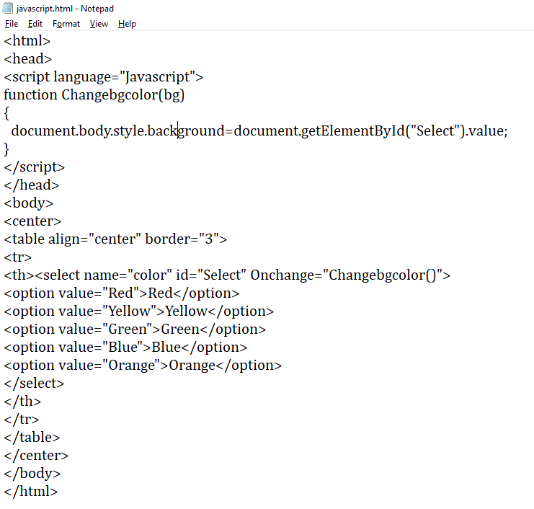

**Output:**

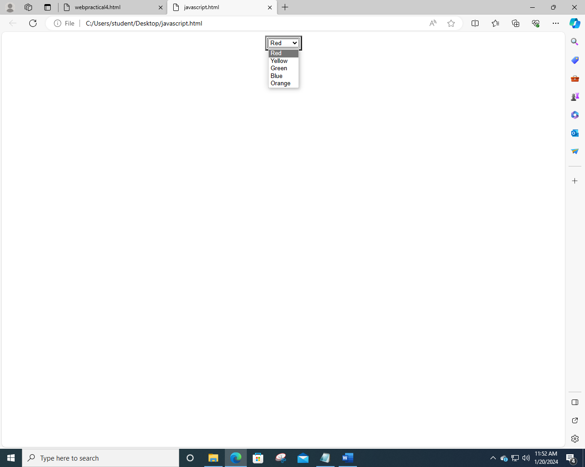

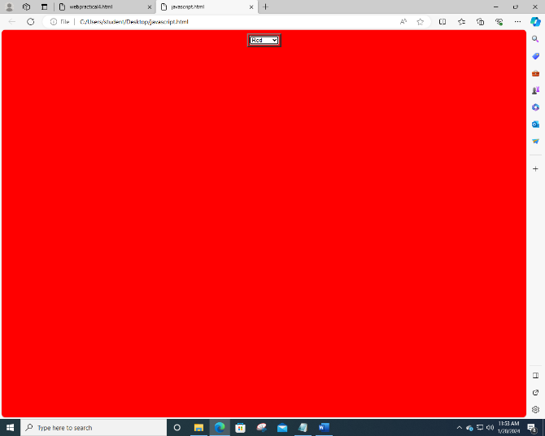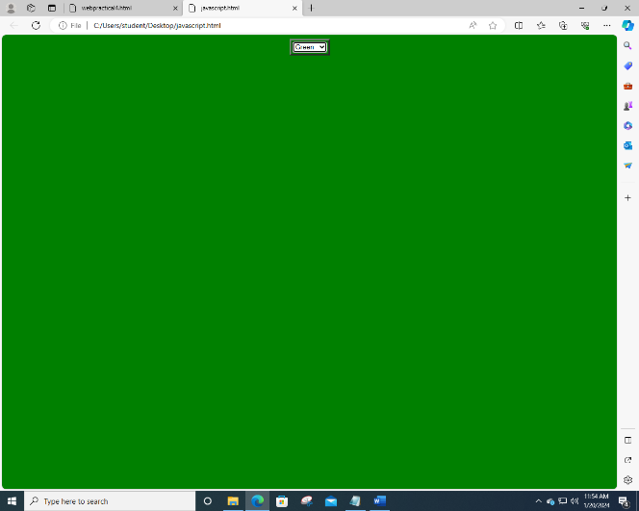 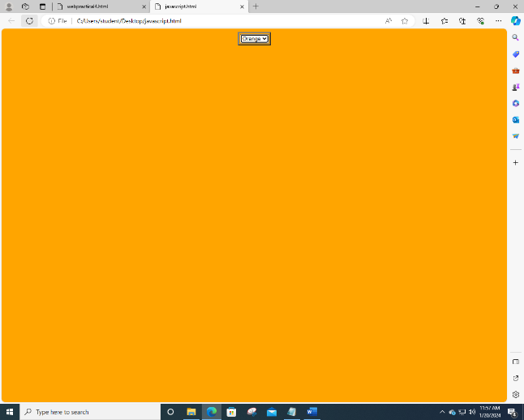

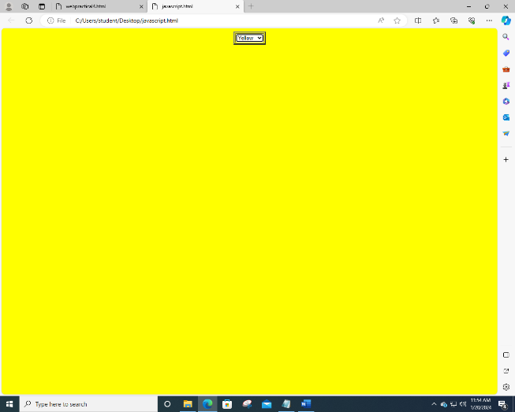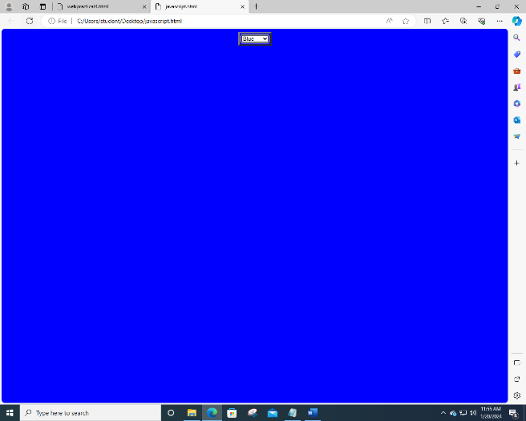

* Implement the string functions.

Code:

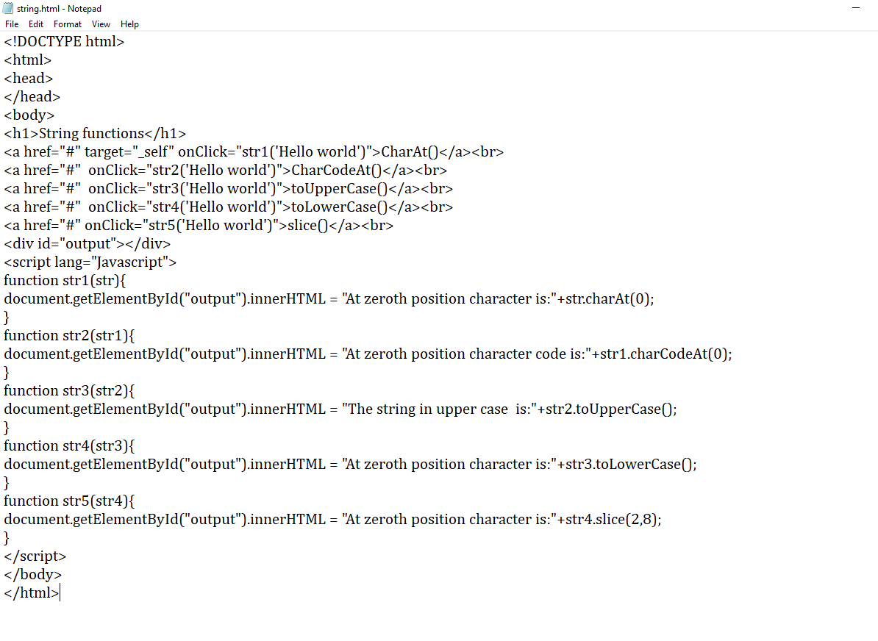

Output:

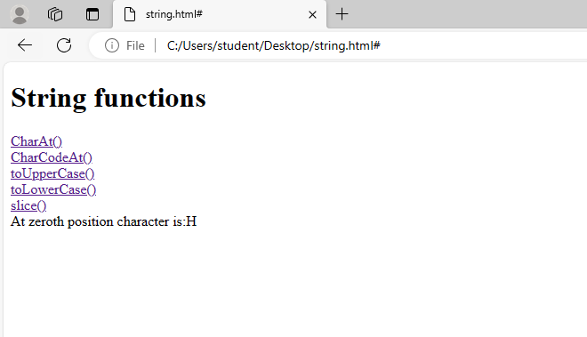

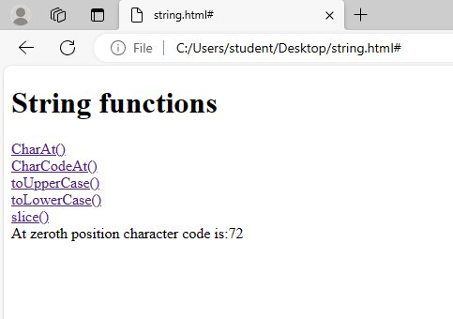

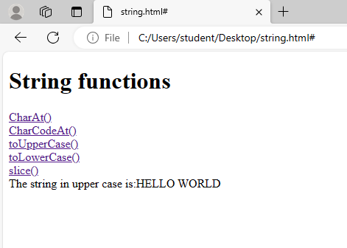

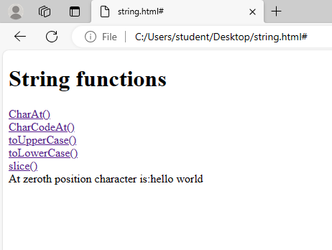

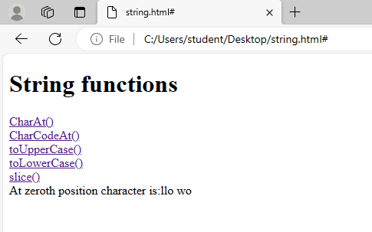

PRACTICAL 5:

Form validation without new window

<!DOCTYPE html>

<html>

<head>

<title>Form Validation</title>

</head>

<body>

<script>

window.onload = function() {

var images = ['clock.jpg', 'img1.jpg'];

var randomIndex = Math.floor(Math.random() * images.length);

var randomImage = images[randomIndex];

var imgElement = document.getElementById('myImage');

imgElement.src = randomImage;

imgElement.width = 250; // Set width to 200 pixels

imgElement.height = 200; // Set height to 100 pixels

}

function validateForm() {

var studentId = document.getElementById('studentId').value;

var firstName = document.getElementById('firstName').value;

var lastName = document.getElementById('lastName').value;

var telephoneNumber = document.getElementById('telephoneNumber').value; var email = document.getElementById('email').value;

var favouriteColour =

document.querySelectorAll('input[name="favouriteColour"]:checked').length; var hobbies = document.querySelectorAll('input[name="hobbies"]:checked').length; var city = document.getElementById('city').value;

// Check if any compulsory field is empty

if (studentId === "" || firstName === "" || lastName === "" || telephoneNumber === "" || email === "" || favouriteColour === 0 || hobbies === 0 || city === "") { alert("Please fill in all compulsory fields and select at least one option for favourite colour, hobbies, and city.");

return false;

}

// Validate Student ID

if (!studentId.match(/^\d{8}$/)) {

alert("Invalid Student ID");

return false;

}

// Validate First Name and Last Name

if (!firstName.match(/^[A-Za-z]+$/) || !lastName.match(/^[A-Za-z]+$/)) { alert("Invalid First Name or Last Name");

return false;

}

// Validate Telephone Number

if (!telephoneNumber.match(/^\d{10}$/)) {

alert("Invalid Telephone Number");

return false;

}

// Validate Email

if (!validateEmail(email)) {

alert("Invalid Email Address");

return false;

}

// Form is valid

return true;

}

// Email validation function

function validateEmail(email) {

var re = /\S+@\S+\.\S+/;

return re.test(email);

}

</script>

<img id="myImage" src="img3.jpg" width="20%" height="9%"> <h2>Form Validation</h2>

<form id="studentForm">

<label for="studentId">Student ID:</label>

<input type="text" id="studentId" name="studentId"><br>

<label for="firstName">First Name:</label>

<input type="text" id="firstName" name="firstName"><br>

<label for="lastName">Last Name:</label>

<input type="text" id="lastName" name="lastName"><br>

<label for="address">Address:</label>

<textarea name="address" rows="10" cols="30"></textarea><br> <label for="city">City:</label>

<select id="city" name="city">

<option value="Mumbai" selected>Mumbai</option>

<option value="Delhi">Delhi</option>

<option value="Bangalore">Bangalore</option>

<option value="Kolkata">Kolkata</option>

<option value="Chennai">Chennai</option>

</select><br>

<label for="telephoneNumber">Telephone Number:</label> <input type="tel" id="telephoneNumber" name="telephoneNumber"><br> <label for="favouriteColour">Favourite Colour:</label><br> <input type="radio" id="red" name="favouriteColour" value="Red"> <label for="red">Red</label><br>

<input type="radio" id="blue" name="favouriteColour" value="Blue"> <label for="blue">Blue</label><br>

<input type="radio" id="green" name="favouriteColour" value="green"> <label for="green">Green</label><br>

<input type="radio" id="yellow" name="favouriteColour" value="yellow"> <label for="yellow">Yellow</label><br>

<input type="radio" id="orange" name="favouriteColour" value="orange"> <label for="orange">Orange</label><br>

<input type="radio" id="black" name="favouriteColour" value="black"> <label for="black">Black</label><br>

<label for="hobbies">Hobbies:</label><br>

<input type="checkbox" id="reading" name="hobbies" value="Reading"> <label for="reading">Reading</label><br>

<input type="checkbox" id="sports" name="hobbies" value="Sports"> <label for="sports">Sports</label><br>

<input type="checkbox" id="adventure" name="hobbies" value="Adventure"> <label for="adventure">Adventure</label><br>

<input type="checkbox" id="music" name="hobbies" >

<label for="music">Music</label><br>

<input type="checkbox" id="travel" name="hobbies" >

<label for="travel">Travel</label><br>

<input type="checkbox" id="games" name="hobbies" ">

<label for="reading">Games</label><br>

<label for="email">Email:</label>

<input type="email" id="email" name="email"><br>

<input type="button" value="Validate" onclick="validateForm()">

<input type="reset" value="Reset">

</form>

</body>

</html>

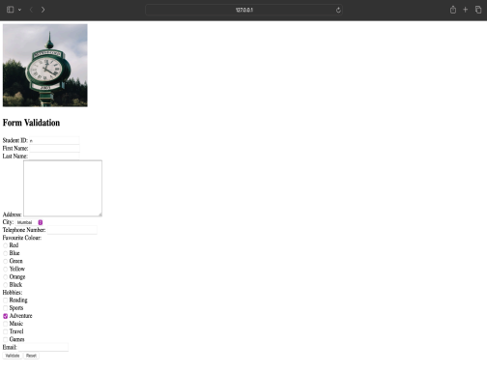Form with new window

<!DOCTYPE html>

<html>

<head>

<title>Form Validation</title>

</head>

<body>

<script>

function validateForm() {

var studentId = document.getElementById('studentId').value;

var firstName = document.getElementById('firstName').value;

var lastName = document.getElementById('lastName').value;

var address = document.querySelector('textarea[name="address"]').value; var city = document.getElementById('city').value;

var telephoneNumber = document.getElementById('telephoneNumber').value; var email = document.getElementById('email').value;

var favouriteColour =

document.querySelector('input[name="favouriteColour"]:checked');

var hobbies = document.querySelectorAll('input[name="hobbies"]:checked');

// Check if any compulsory field is empty

if (studentId === "" || firstName === "" || lastName === "" || address === "" || city === "" || telephoneNumber === "" || email === "" || favouriteColour === null || hobbies.length === 0) {

alert("Please fill in all compulsory fields and select at least one option for favourite colour, hobbies, and city.");

return false;

}

// Validate Student ID

if (!studentId.match(/^\d{8}$/)) {

alert("Invalid Student ID");

return false;

}

// Validate First Name and Last Name

if (!firstName.match(/^[A-Za-z]+$/) || !lastName.match(/^[A-Za-z]+$/)) { alert("Invalid First Name or Last Name");

return false;

}

// Validate Telephone Number

if (!telephoneNumber.match(/^\d{10}$/)) {

alert("Invalid Telephone Number");

return false;

}

// Validate Email

if (!validateEmail(email)) {

alert("Invalid Email Address");

return false;

}

// Open new window with student data

var newWindow = window.open("", "Student Data", "width=400,height=400"); var content = "<h2>Student Data</h2>";

content += "<p><strong>Student ID:</strong> " + studentId + "</p>"; content += "<p><strong>First Name:</strong> " + firstName + "</p>"; content += "<p><strong>Last Name:</strong> " + lastName + "</p>"; content += "<p><strong>Address:</strong> " + address + "</p>";

content += "<p><strong>City:</strong> " + city + "</p>";

content += "<p><strong>Telephone Number:</strong> " + telephoneNumber + "</p>"; content += "<p><strong>Email:</strong> " + email + "</p>";

content += "<p><strong>Favourite Colour:</strong> " + favouriteColour.value + "</p>"; content += "<p><strong>Hobbies:</strong> ";

hobbies.forEach(function(hobby) {

content += hobby.value + ", ";

});

content = content.slice(0, -2); // Remove trailing comma and space content += "</p>";

newWindow.document.write(content);

}

// Email validation function

function validateEmail(email) {

var re = /\S+@\S+\.\S+/;

return re.test(email);

}

function resetForm() {

document.getElementById("studentForm").reset();

}

</script>

<h2>Form Validation</h2>

<form id="studentForm">

<label for="studentId">Student ID:</label>

<input type="text" id="studentId" name="studentId"><br>

<label for="firstName">First Name:</label>

<input type="text" id="firstName" name="firstName"><br>

<label for="lastName">Last Name:</label>

<input type="text" id="lastName" name="lastName"><br>

<label for="address">Address:</label>

<textarea name="address" rows="10" cols="30"></textarea><br> <label for="city">City:</label>

<select id="city" name="city">

<option value="Mumbai" selected>Mumbai</option>

<option value="Delhi">Delhi</option>

<option value="Bangalore">Bangalore</option>

<option value="Kolkata">Kolkata</option>

<option value="Chennai">Chennai</option>

</select><br>

<label for="telephoneNumber">Telephone Number:</label> <input type="tel" id="telephoneNumber" name="telephoneNumber"><br> <label for="favouriteColour">Favourite Colour:</label><br> <input type="radio" id="red" name="favouriteColour" value="Red"> <label for="red">Red</label><br>

<input type="radio" id="blue" name="favouriteColour" value="Blue"> <label for="blue">Blue</label><br>

<input type="radio" id="orange" name="favouriteColour" value="Orange"> <label for="orange">Orange</label><br>

<input type="radio" id="black" name="favouriteColour" value="Black"> <label for="black">Black</label><br>

<input type="radio" id="green" name="favouriteColour" value="Green"> <label for="green">Green</label><br>

<input type="radio" id="yellow" name="favouriteColour" value="Yellow"> <label for="yellow">Yellow</label><br>

<label for="hobbies">Hobbies:</label><br>

<input type="checkbox" id="reading" name="hobbies" value="Reading"> <label for="reading">Reading</label><br>

<input type="checkbox" id="music" name="hobbies" value="Music"> <label for="music">Music</label><br>

<input type="checkbox" id="games" name="hobbies" value="Games"> <label for="games">Games</label><br>

<input type="checkbox" id="adventure" name="hobbies" value="Adventure"> <label for="adventure">Adventure</label><br>

<input type="checkbox" id="sports" name="hobbies" value="Sports"> <label for="sports">Sports</label><br>

<input type="checkbox" id="travel" name="hobbies" value="Travel"> <label for="travel">Travel</label><br>

<label for="email">Email:</label>

<input type="email" id="email" name="email"><br>

<input type="button" value="Validate" onclick="validateForm()"> <input type="button" value="Reset" onclick="resetForm()"> </form>

</body>

</html>

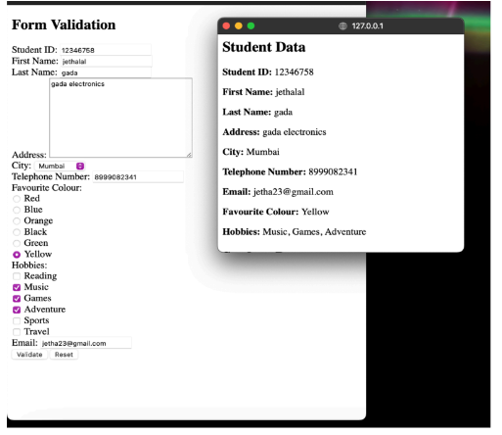

**PRACTICA 6: jQuery**

1. Write programs to display jQuery effects using events & selectors:
2. To hide a paragraph while clicking on the paragraph.

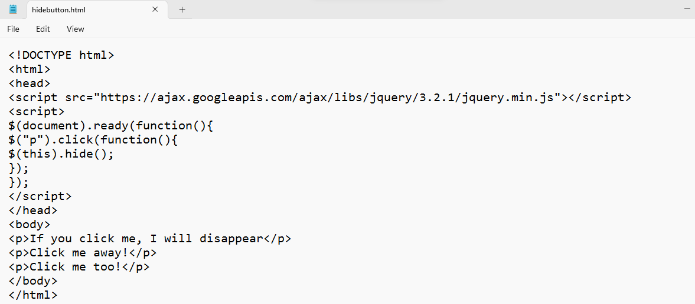

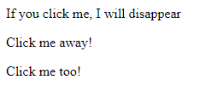 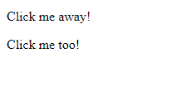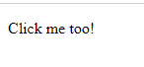 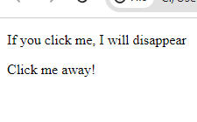

1. Hide a paragraph by clicking on the button.

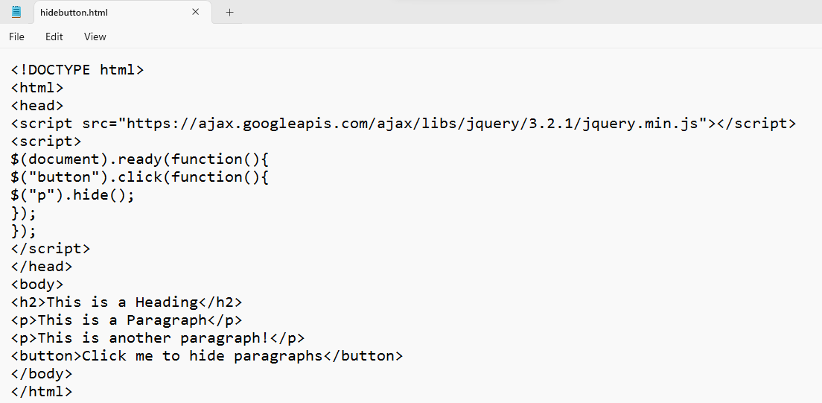



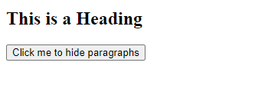

1. A page with two buttons with show and hide…When clicked on one button it will hid the paragraph & clicked on other will display the paragraph back.

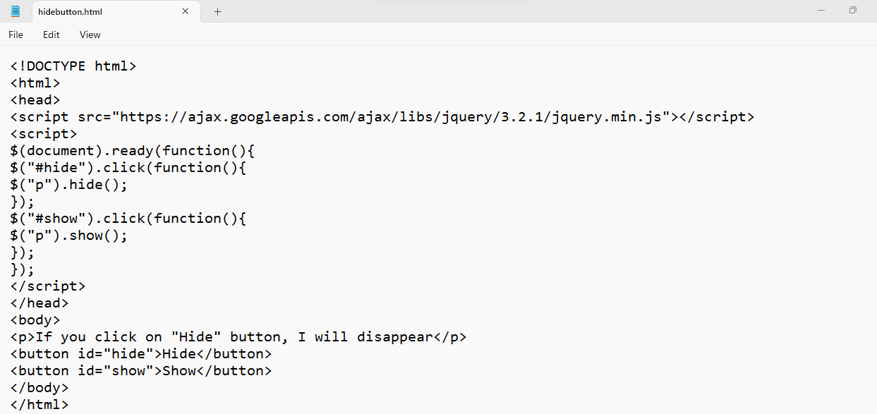

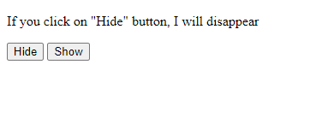 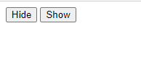

d) Write a program to implement jQuery Events

Mouse enter()

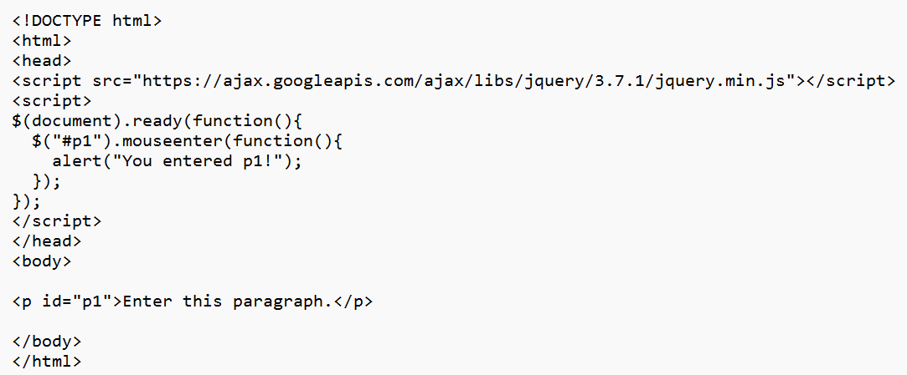

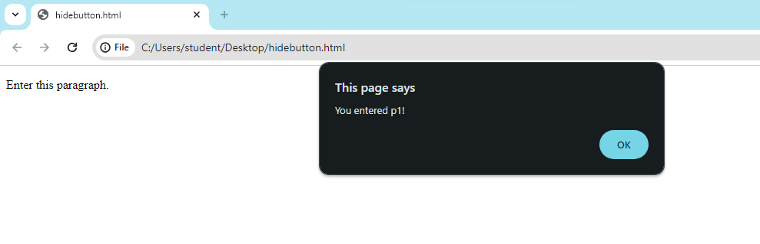

Mouseleave()

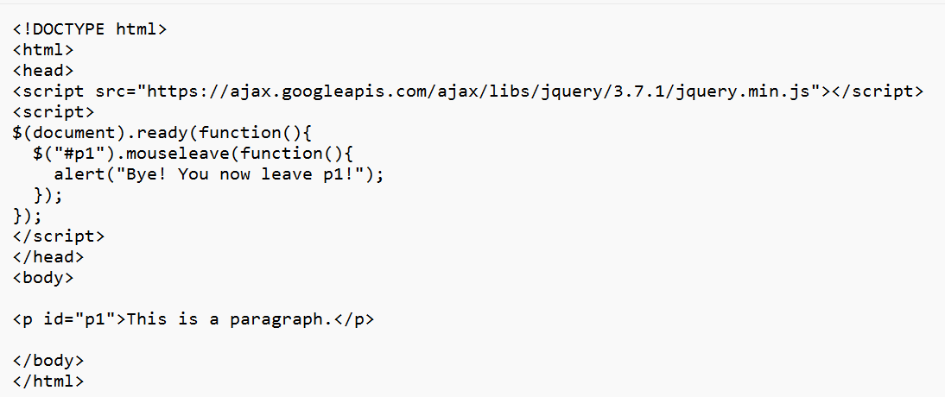

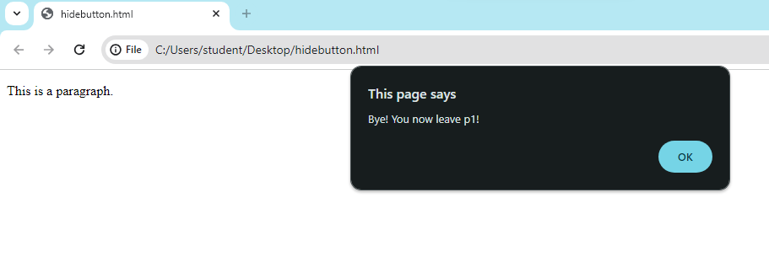

Mousedown()

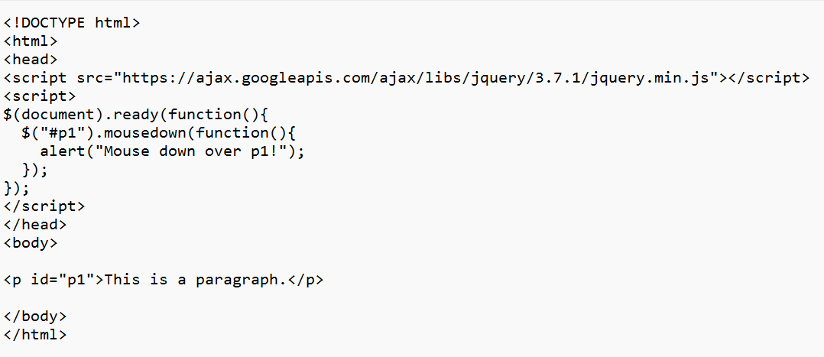

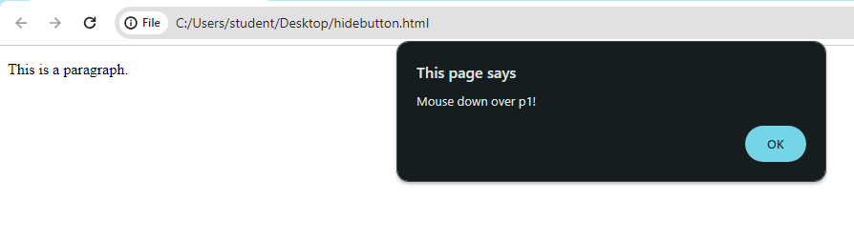

Mouseup()

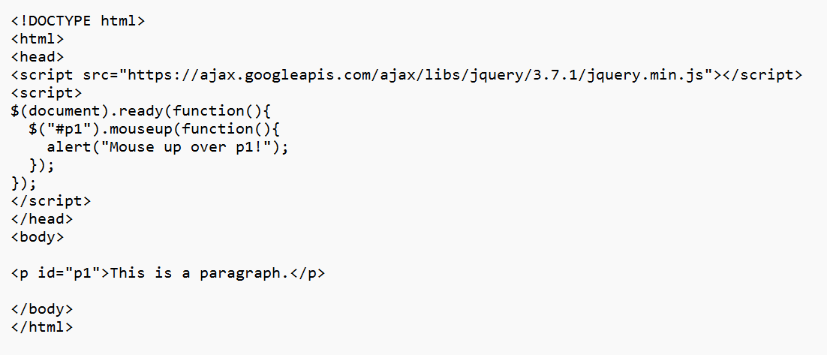

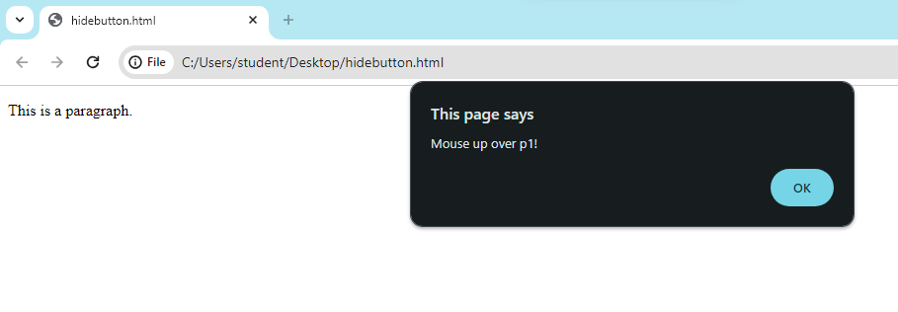

Hover()

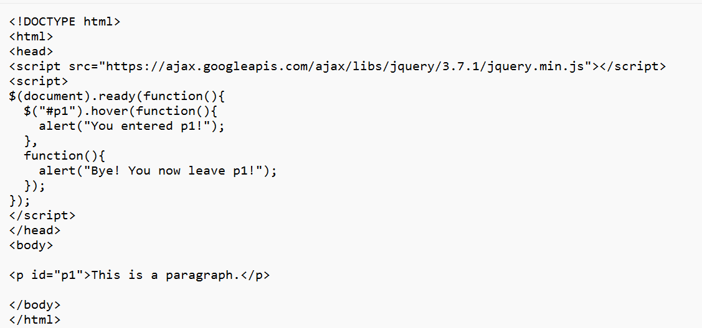

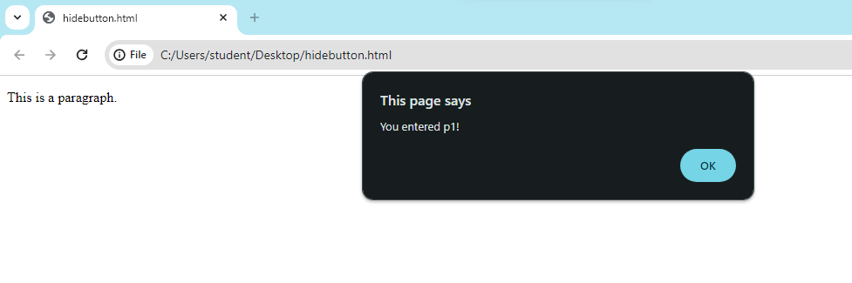

Focus()

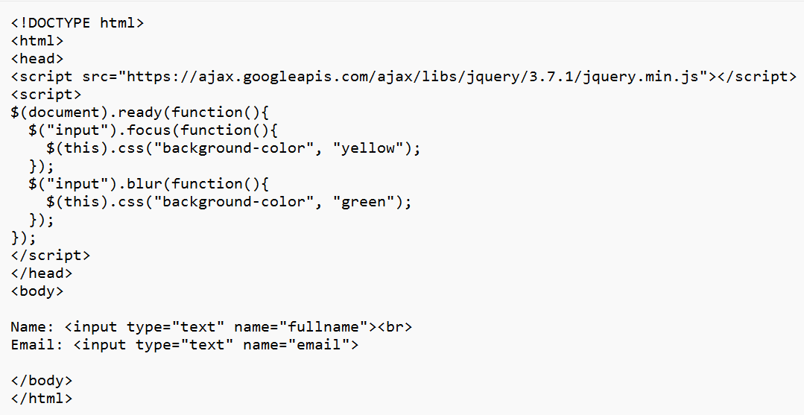

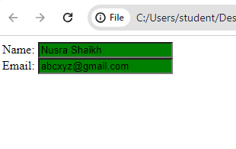

Blur()

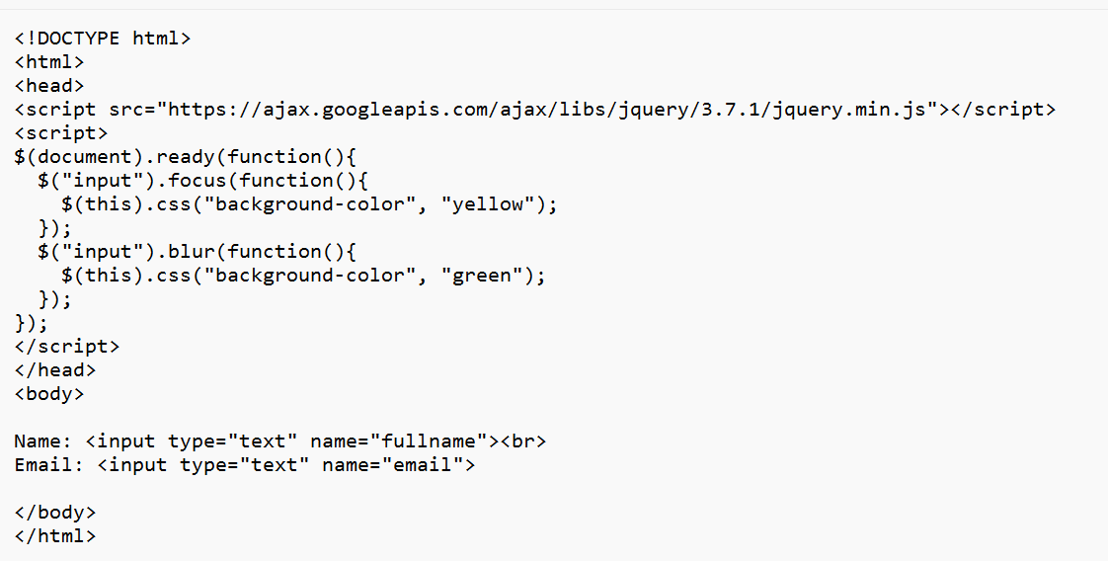

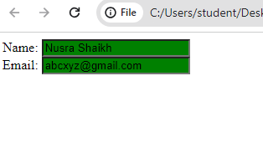

On()

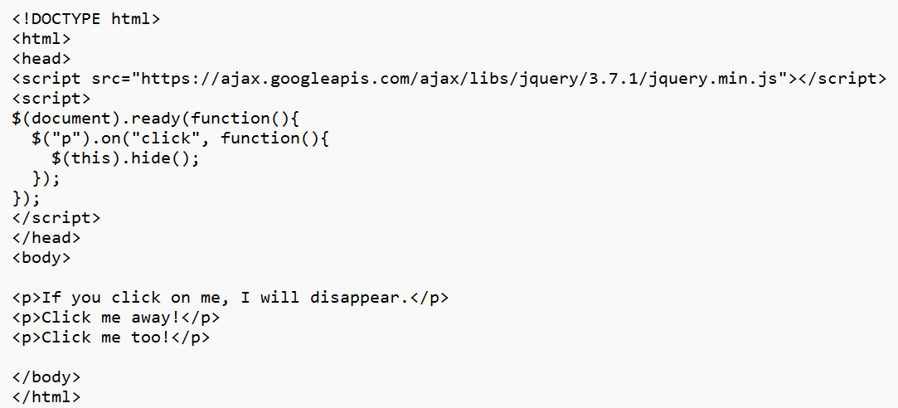

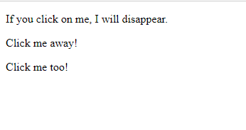

PRACTICAL 7: jQuery

1. Design a Webpage with some jQuery effects, Animation effects.

1. Fade In()

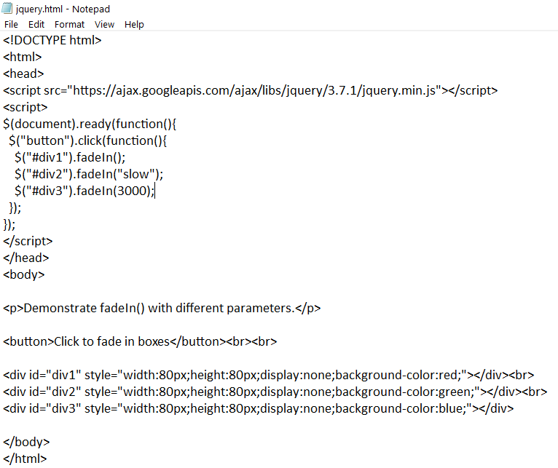

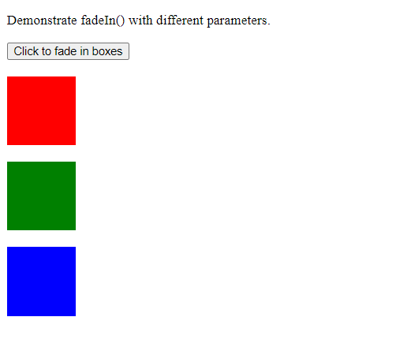

2. fadeOut()

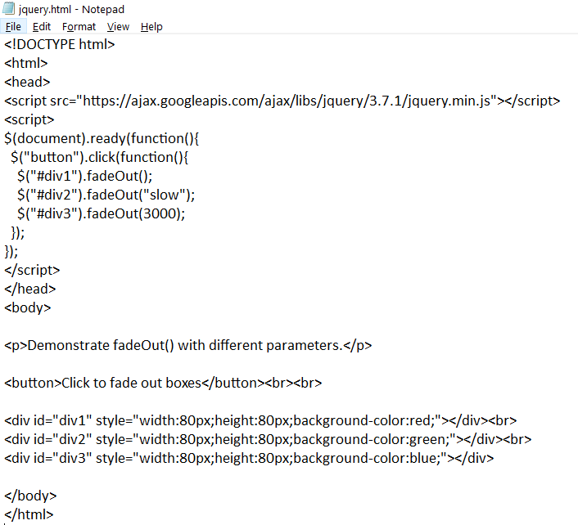

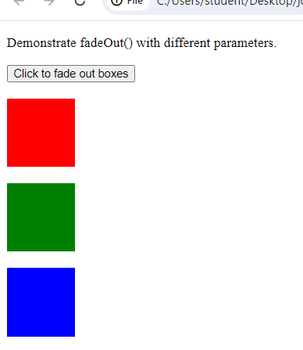 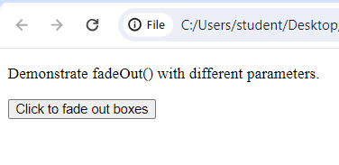  
3. fadeToggle()

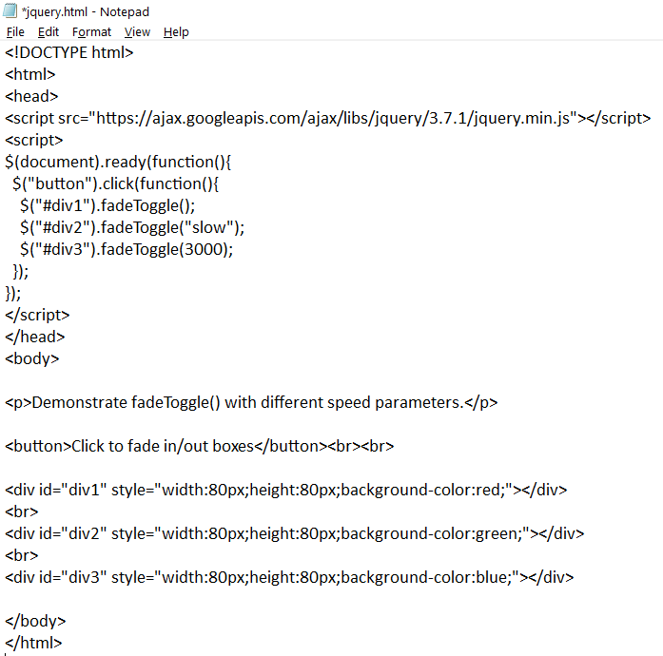

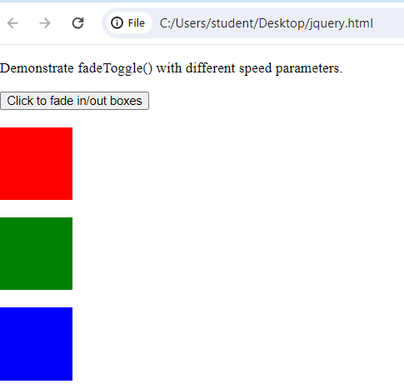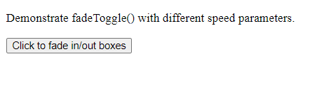  
4. fadeTo()

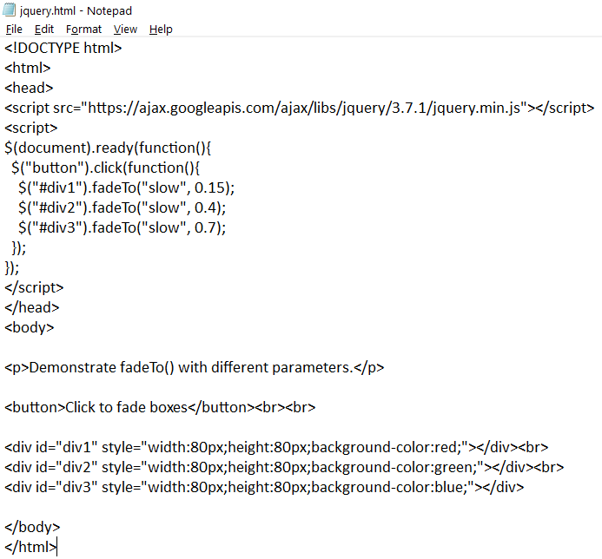

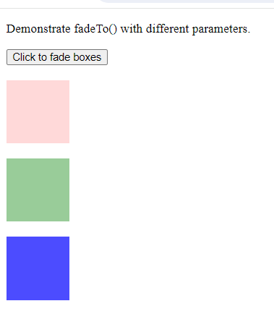  
5. slideDown()

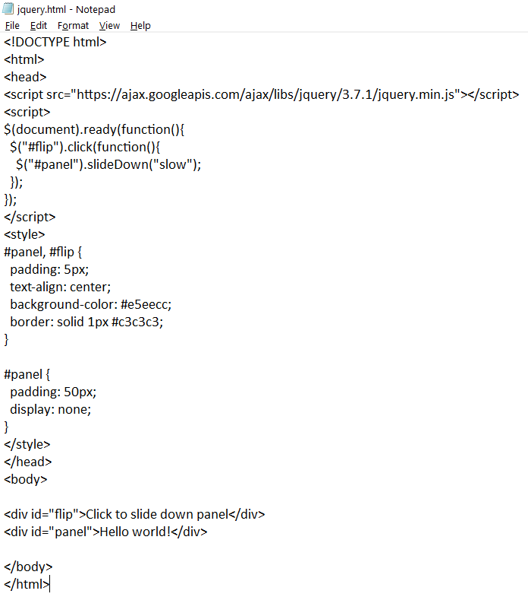

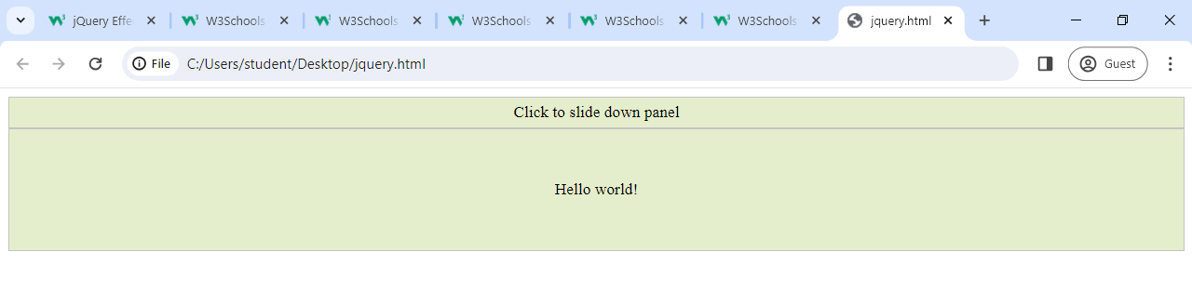  
6.slideUp()

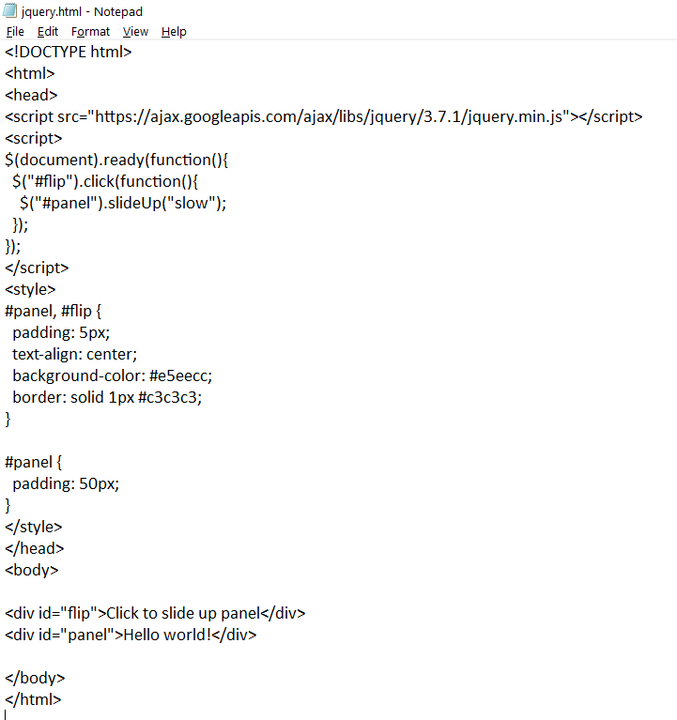

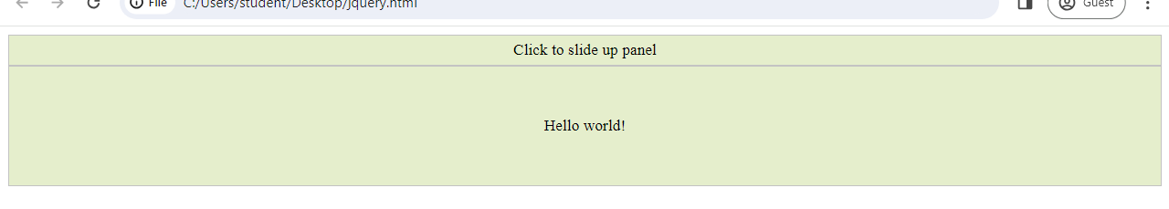

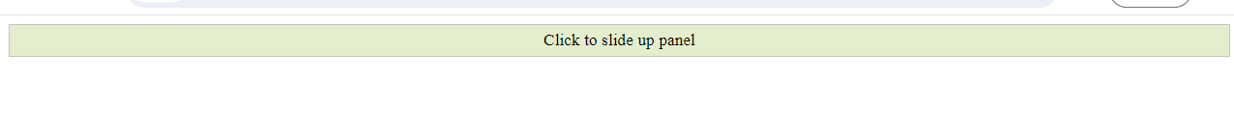  
7. slideToggle()

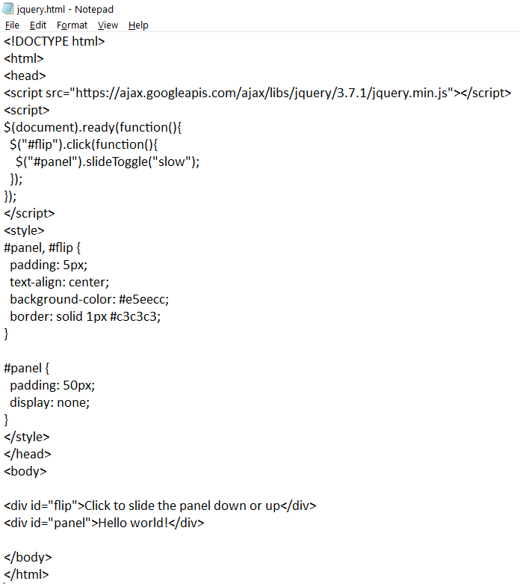

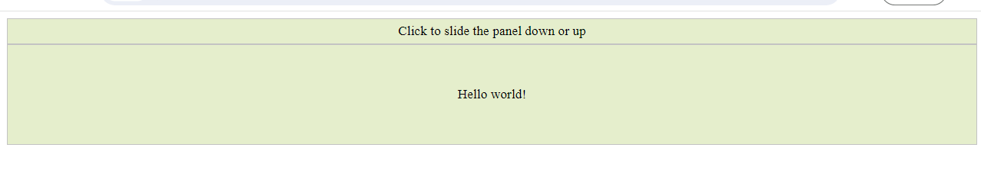



8. animate()

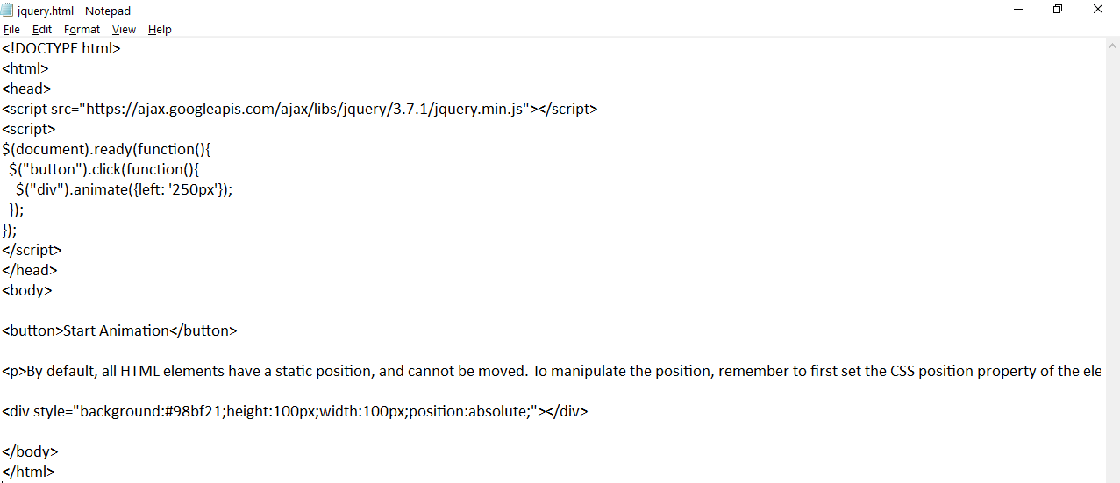

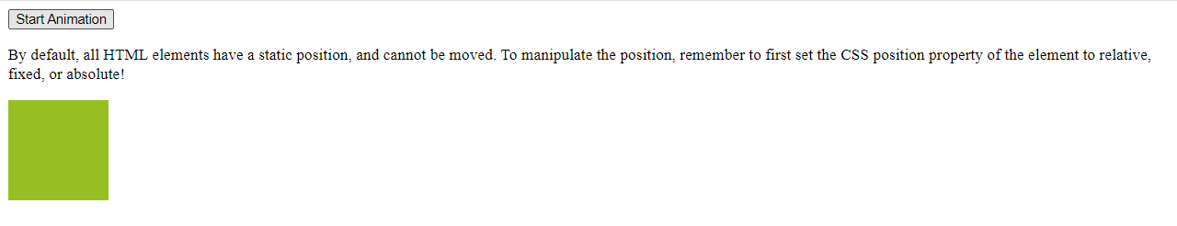

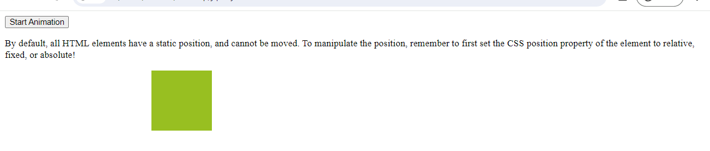

**PRACTICAL 8 : AJAX**

**Design a  webpage to handle asynchronous requests using AJAX on:**

**a. Button click**

**CODE:**

<!DOCTYPE html>

<html>

<body>

<div id="demo">

<h2> The XMLHttpRequest Object</h2>

<button type ="button" onclick="loadDoc()">Change Content</button>

</div>

<script>

function loadDoc(){

var xhttp=new XMLHttpRequest();

xhttp.onreadystatechange=function(){

if(this.readyState == 4 && this.status == 200){

document.getElementById("demo").innerHTML=

this.responseText;

}

};

xhttp.open("GET","ajaxinfo.txt",true);

xhttp.send();

}

</script>

</body>

</html>

**OUTPUT:**

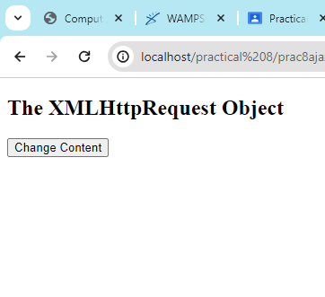

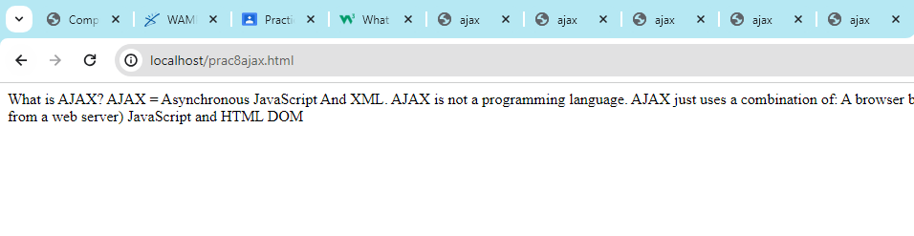

**b. Mouse over**

**CODE:**

<html>

<head>

<title>Ajax mouse over</title>

<script language="javascript">

var XMLHttpRequestObject=false;

if (window.XMLHttpRequest){

XMLHttpRequestObject = new XMLHttpRequest();

}else if(window.ActiveXObject){

XMLHttpRequestObject=new ActiveXObject("Microsoft.XMLHTTP");

}

function getData(dataSource,divID)

{

if(XMLHttpRequestObject){

var obj=document.getElementById(divID);

XMLHttpRequestObject.open("GET",dataSource);

XMLHttpRequestObject.onreadystatechange=function()

{

if(XMLHttpRequestObject.readyState == 4 && XMLHttpRequestObject.status == 200)

{

obj.innerHTML=XMLHttpRequestObject.responseText;

}

}

XMLHttpRequestObject.send(null);

}

}

</script>

</head>

<body>

<h1>Interactive mouseovers</h1>

<img src="sandwich.jpg" onmouseover="getData('sandwich.txt','targetDiv')">

<img src='pizza.jpg' onmouseover="getData('pizza.txt','targetDiv')">

<img src='soup.jpg' onmouseover="getData('soup.txt','targetDiv')">

<div id="targetDiv">

<p>The fetched data will go here</p>

</div>

</body>

</html>

**OUTPUT:**

**MOUSEOVER ON SANDWICH:**

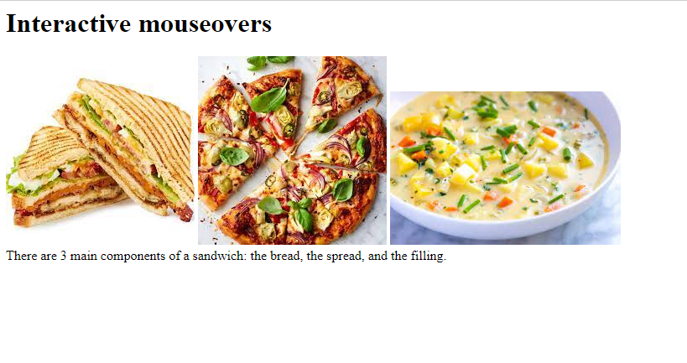

**MOUSEOVER ON PIZZA**

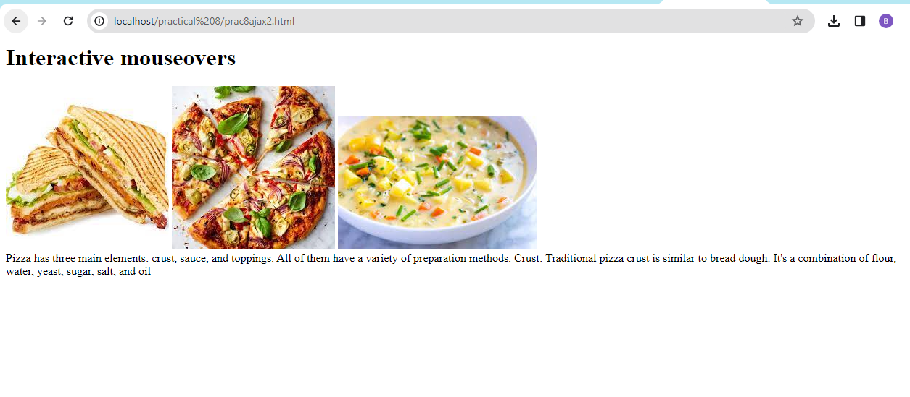

**MOUSEOVER ON SOUP:**

